
American International University-Bangladesh (AIUB)
Faculty of Science & Technology (FST)
Department of Computer Science
Introduction to Data Science
Mid-Term Project Report
Spring 2025-2026
Section: B
Group: 6

Project Contributions
SL  # | Student Name & ID | Contributions (mention every part of the project where you contributed)
1. | Name: Shanto Md. Shahariyar Kabir  ID: 23-50028-1 | Task 1, Task 5, Task 9
2. | Name: Mohsin Ibna Hossain  ID: 23-50194-1 | Task 3, Task 7, Task 11, Report Writing
3. | Name: Foujia Faruk  ID: 23-50247-1 | Task 2, Task 6, Task 10
4. | Name: Rajarshi Mondal  ID: 23-50279-1 | Task 4, Task 8, Task 12

Dataset Description
The selected dataset contains various indicators of student mental health, including demographic information (Age, Gender), academic stressors (Academic Performance, Stress Level), and mental health states (Depression, Anxiety, Suicide Attempt). The dataset consists of 1100 records and 12 attributes. The primary goal is to perform exploratory data analysis and prepare the data for predictive modelling by addressing missing values, outliers, and balancing the target class ("Suicide Attempt").
Project Implementation Detail
1. Handling Missing Values in the Dataset
The objective of this task is to manage missing data within the student performance dataset to ensure the quality and integrity of subsequent analyses. Missing values can lead to biased results or errors in statistical modelling, so they must be addressed systematically.
How I solved it: I implemented two distinct methods for handling missing values using R:
- Discard Instances: This approach removes any observation (row) that contains one or more missing values. It is useful when the number of missing values is small relative to the total dataset size.
- Replace by Most Frequent / Average Value (Imputation): This approach fills in the gaps rather than deleting rows.
  - For numeric columns (like Age), missing values are replaced with the Rounded Mean (Average rounded to the nearest whole number).
  - For categorical columns (like Health Condition or Relationship Condition), missing values are replaced with the Mode (Most Frequent value).
Code
na_values <- c("", " ", "NA")
dataset <- read.csv("Final_SP_dataSet.csv", na.strings = na_values)

cat("\n--- Task 1: Handling Missing Values in the Dataset ---\n")
missing_counts <- colSums(is.na(dataset))
cat("Missing values per column before processing:\n")
print(missing_counts)

cat("Method 1: Discard Instances\n")
dataset_discarded <- na.omit(dataset)
cat("\nMethod 1: Discard Instances\n")
cat("Original rows:", nrow(dataset), "\n")
cat("Rows after discarding instances:", nrow(dataset_discarded), "\n")

cat("Method 2: Replace by Most Frequent / Average Value\n")
dataset_replaced <- dataset

get_mode <- function(v) {
v <- v[!is.na(v)]
uniqv <- unique(v)
uniqv[which.max(tabulate(match(v, uniqv)))]
}

for (col in names(dataset_replaced)) {
if (any(is.na(dataset_replaced[[col]]))) {
if (is.numeric(dataset_replaced[[col]])) {
dataset_replaced[[col]][is.na(dataset_replaced[[col]])] <- round(mean(dataset_replaced[[col]], na.rm = TRUE))
} else {
dataset_replaced[[col]][is.na(dataset_replaced[[col]])] <- get_mode(dataset_replaced[[col]])
}
}
}

cat("\nMethod 2: Replace by Most Frequent / Average Value\n")
cat("Remaining missing values after replacement:\n")
print(colSums(is.na(dataset_replaced)))

Output:
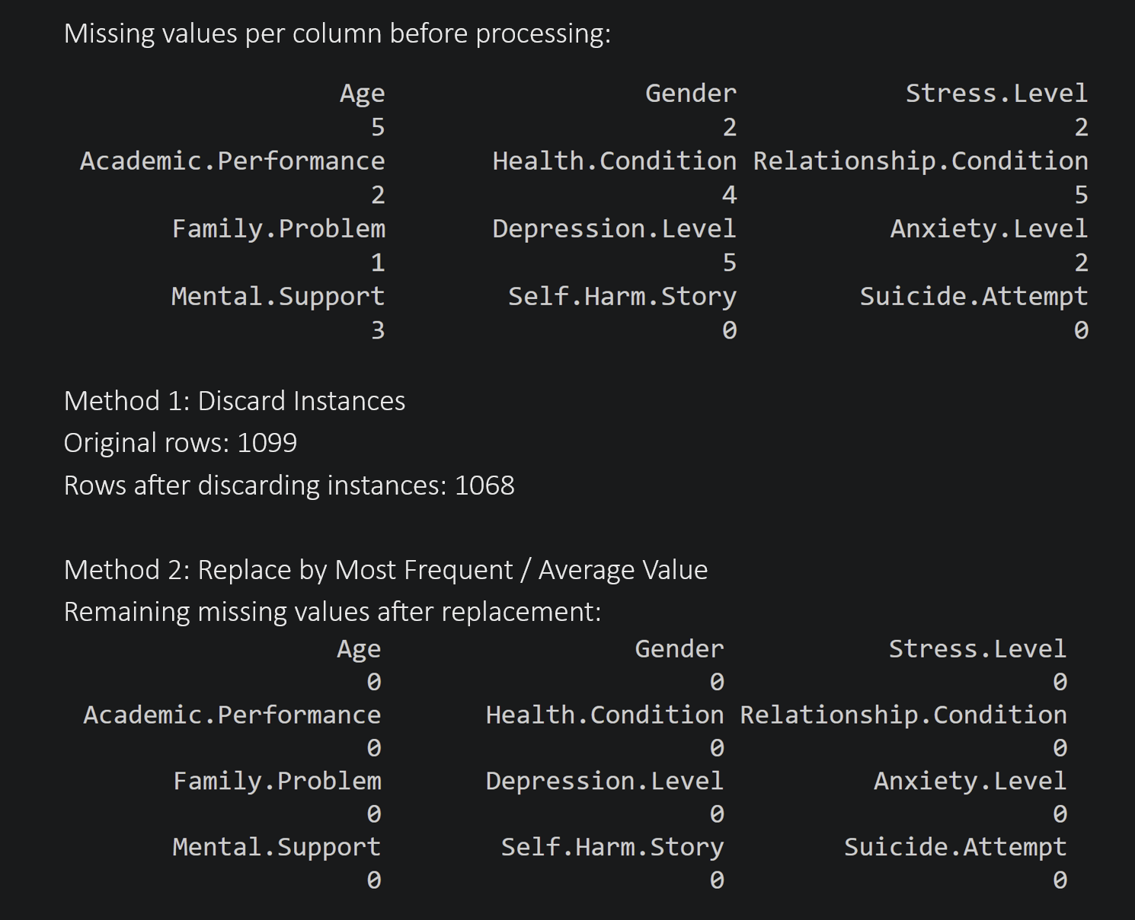
The output demonstrates the transition of the dataset from having missing values to being fully cleaned.
- Initialization: The script first identifies that columns like Age, Health Condition, and Relationship Condition contain missing values (represented as NA).
- Method 1 (Discarding): The output shows the reduction in the total number of rows. In this specific dataset, 31 rows contained at least one missing value and were removed, leaving the dataset with only "complete cases."
- Method 2 (Replacement): Instead of reducing the row count, this method successfully filled all NA values. According to the logic, the missing Age values were replaced by the calculated mean age of the students, while the categorical fields were filled with the most common entry in those columns. The final check (colSums(is.na(...))) confirms that 0 missing values remain after the imputation process.
2. Outlier Detection and Handling for 'Age'
The goal of this task is to identify and address outliers in the numerical columns of the dataset. Outliers are observations that are significantly distant from other observations, which can skew statistical results and impact the accuracy of any predictive models.
How I solved it: I used the Interquartile Range (IQR) Method to solve this:
Detection: Computed the 25th percentile (Q1) and 75th percentile (Q3). Calculated the IQR (Q3−Q1). Defined bounds as Q1−1.5∗IQR (Lower Bound) and Q3+1.5∗IQR (Upper Bound). Any value outside these bounds is considered an outlier.
Handling: I chose the Capping (Winsorization) approach. Instead of deleting the outliers, I replaced values below the lower bound with the lower bound itself, and values above the upper bound with the upper bound. This keeps the data size consistent while removing the extreme variance.
Code
dataset_outlier_handled <- dataset_replaced

handle_outliers_iqr <- function(data_vec) {
Q1 <- quantile(data_vec, 0.25, na.rm = TRUE)
Q3 <- quantile(data_vec, 0.75, na.rm = TRUE)
IQR_val <- Q3 - Q1

lower_bound <- Q1 - 1.5 * IQR_val
upper_bound <- Q3 + 1.5 * IQR_val

outliers <- data_vec < lower_bound | data_vec > upper_bound
cat("Outliers detected:", sum(outliers), "\n")
cat("Lower Bound:", lower_bound, " | Upper Bound:", upper_bound, "\n\n")

data_vec[data_vec < lower_bound] <- lower_bound
data_vec[data_vec > upper_bound] <- upper_bound

return(data_vec)
}

cat("\n--- Task 2: Outlier Detection and Handling for 'Age' ---\n")

dataset_outlier_handled$Age <- handle_outliers_iqr(dataset_outlier_handled$Age)

cat("Summary of Age BEFORE outlier handling:\n")
print(summary(dataset_replaced$Age))

cat("\nSummary of Age AFTER outlier handling:\n")
print(summary(dataset_outlier_handled$Age))

Output:
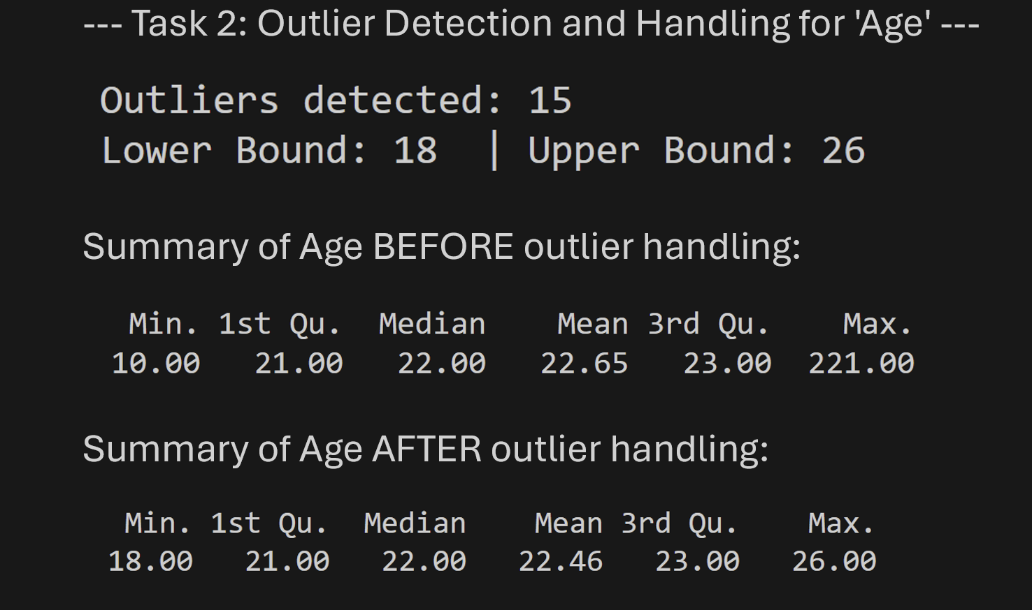
The output shows the effectiveness of the IQR method in constraining extreme values:
- Detection: The script identified 15 outliers in the Age column where values were either below 18 or above 26.
- Correction: By looking at the BEFORE summary, the maximum age was 221.00, which was far above the upper bound of 26. After applying the capping logic, the AFTER summary shows the Max value is now 26.
- Result: The extreme variance has been removed, providing a more normalized distribution of ages for analysis without losing any records from the dataset.
3. Attribute Conversion (Numeric to Categorical & Categorical to Numeric)
This task focuses on data transformation to support various analytical and machine learning tasks. Categorical variables are often converted to numeric formats for mathematical modeling, while numeric variables are converted to categories for grouping or segmentation (binning).
How I solved it: My implementation addresses both directions using R:
- Categorical to Numeric (Ordinal Encoding): I mapped the ordinal categories of Stress Level (Low, Moderate, High) to numeric ranks (1, 2, 3) and Academic Performance (Poor, Average, Good, Excellent) to ranks (1, 2, 3, 4). Special care was taken to trim whitespace from labels (e.g., 'Good ') to prevent mapping errors.
- Numeric to Categorical (Binning): I converted the continuous Age column into a discrete categorical Age_Group using predefined breaks: 0-19 (Teen), 20-29 (Youth), and 30+ (Adult) using the cut() function.
Code
dataset_converted <- dataset_outlier_handled

cat("\n--- Task 3: Attribute Conversion ---\n")

cat("Converting 'Stress Level' to numeric...\n")
dataset_converted$SL_Numeric <- as.numeric(factor(dataset_converted$Stress.Level,
levels = c("Low", "Moderate", "High")
))

cat("Converting 'Academic Performance' to numeric...\n")
cleaned_academic <- gsub("[^[:alpha:]]", "", dataset_converted$Academic.Performance)
dataset_converted$AP_Numeric <- as.numeric(factor(cleaned_academic,
levels = c("Poor", "Average", "Good", "Excellent")
))

cat("Converting 'Age' to categorical Age groups...\n")
dataset_converted$Age_Group <- cut(dataset_converted$Age,
breaks = c(0, 19, 29, Inf),
labels = c("Teen", "Youth", "Adult")
)

cat("\nSample of converted attributes:\n")
print(head(dataset_converted[, c("Age", "Age_Group", "Stress.Level", "SL_Numeric", "Academic.Performance", "AP_Numeric")]))

cat("\nValue counts for new Age_Group column:\n")
print(table(dataset_converted$Age_Group))
Output:
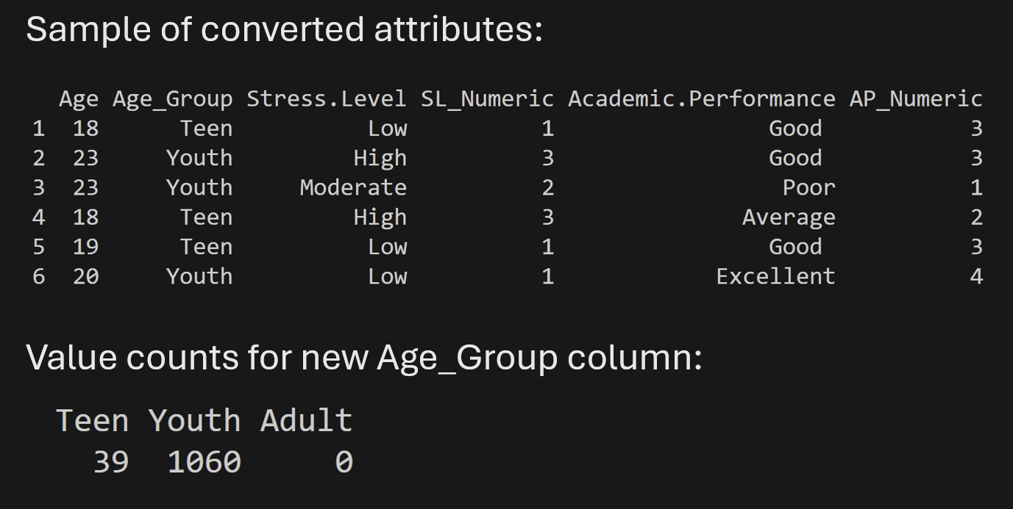
The code successfully created new attributes that represent the data in different formats:
- Feature Expansion: Both the Stress_Level_Numeric and Academic_Performance_Numeric were created. These new numeric columns translate qualitative assessments (like "High Stress") into quantitative values (3), which are better suited for correlation analysis and computational models.
- Segmenting Data: The Age_Group transformation effectively grouped individuals into standard life-stage categories. The frequency table confirms that the majority of participants belong to the "Youth" group (20-29), followed by "Teen" students. This simplifies subsequent analysis where age trends need to be analyzed at a cohort level rather than year-by-year.

4. Normalization of Continuous Attributes
Normalization is a data preparation step that transforms numerical attributes into a standard scale without distorting differences in the ranges of values. This is crucial for algorithms that rely on distance calculations (like K-Means or KNN) to ensure that attributes with larger ranges (like Age) do not unfairly dominate the results.
How I solved it: I implemented Min-Max Normalization in R, which scales the data into a fixed range between 0 and 1. This is ideal for bringing all data to the same starting point without losing the relationship between individual data points.
Formula: $(x-min(x))/(max(x)-min(x))$
Code
dataset_normalized <- dataset_converted

cat("\n--- Task 4: Normalization ---\n")

min_max_norm <- function(x) {
(x - min(x, na.rm = TRUE)) / (max(x, na.rm = TRUE) - min(x, na.rm = TRUE))
}

cat("Applying Min-Max Normalization to 'Age'...\n")
dataset_normalized$Age_Normalized <- min_max_norm(dataset_normalized$Age)

cat("\nSummary of Normalized Age (Min-Max):\n")
print(summary(dataset_normalized$Age_Normalized))

cat("\nSample of normalized results:\n")
print(head(dataset_normalized[, c("Age", "Age_Normalized")]))

Output:
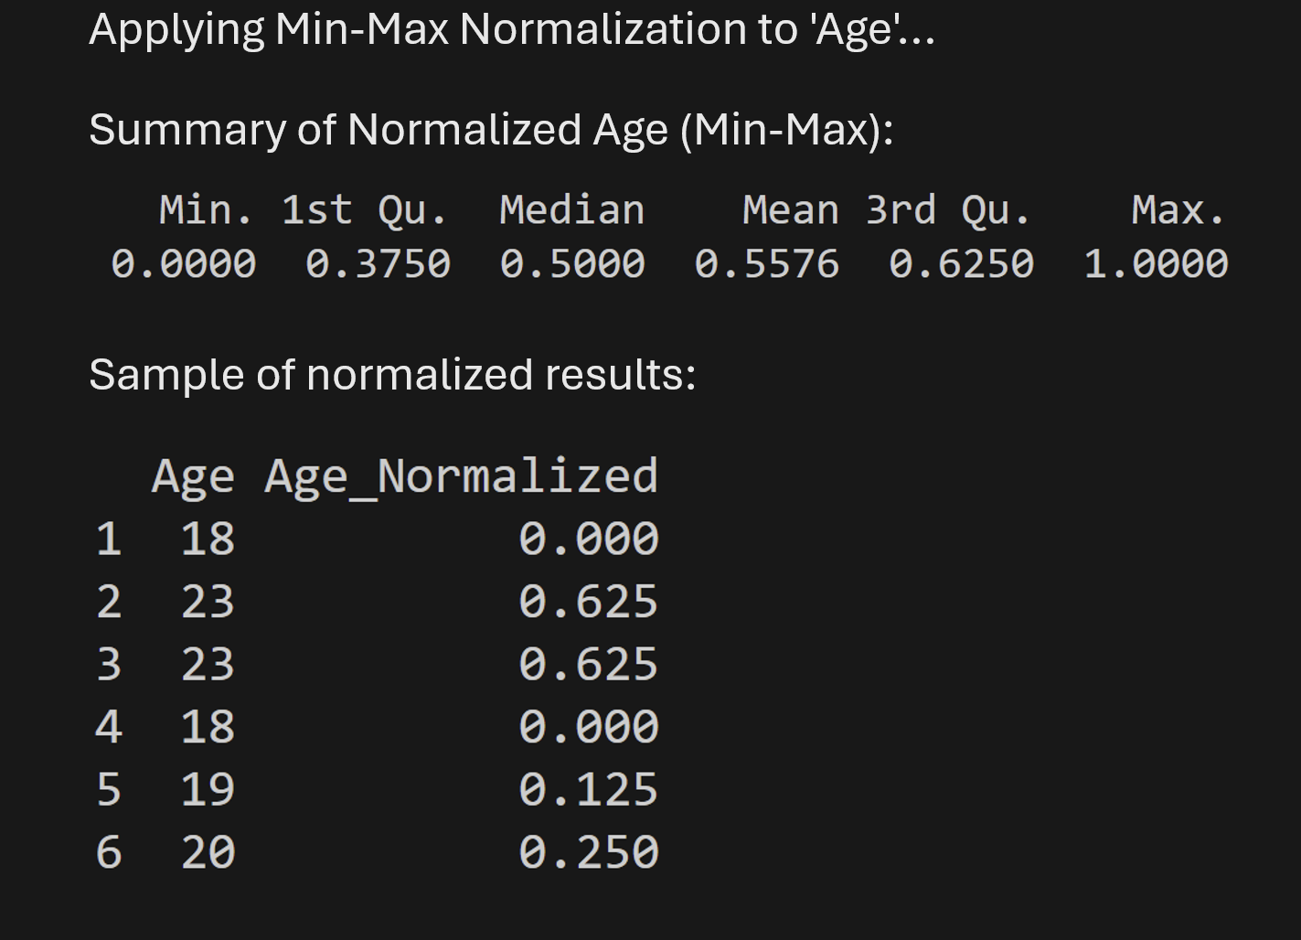
The normalization process transformed the Age attribute into a standard mathematical form:
- Min-Max Consistency: After applying normalization, the age values are bounded strictly within the range of 0.0 to 1.0. For instance, the minimum age in the dataset became 0.0, and the maximum age became 1.0.
- Result: This allows for consistent data analysis regardless of the original units of the attribute.
5. Handle Duplicate Rows
Duplicate entries in a dataset can occur during data collection, merging, or cleaning steps. Keeping multiple identical rows can cause overrepresentation of certain data points and lead to misleading statistical results. This task focus on identifying and cleaning these redundancies.
How I solved it: I utilized R's built-in functions to systematically address this:
- Detection: Used the duplicated() function to identify rows that were identical to a previous row.
- Counting: Calculated the total number of duplicate instances using sum(duplicated(...)).
- Removal: Applied logical subsetting (!duplicated(...)) to generate a cleaned dataset containing only unique entries.
Code
cat("\n--- Task 5: Handle Duplicate Rows ---\n")

duplicate_count <- sum(duplicated(dataset_normalized))
cat("Number of duplicate rows found:", duplicate_count, "\n")

if (duplicate_count > 0) {
cat("Duplicate rows detected. Removing duplicates...\n")
dataset_final <- dataset_normalized[!duplicated(dataset_normalized), ]
} else {
cat("No duplicate rows found. Keeping dataset as is.\n")
dataset_final <- dataset_normalized
}

cat("Original Row Count:", nrow(dataset_normalized), "\n")
cat("Final Row Count (After Removing Duplicates):", nrow(dataset_final), "\n")
Output:
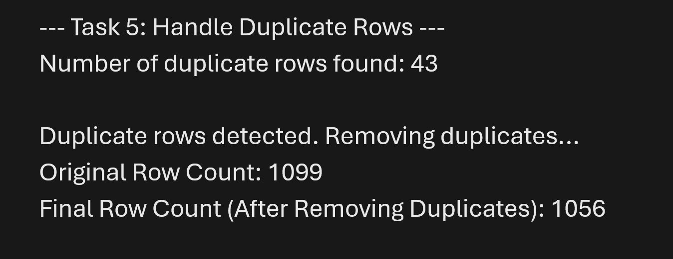
The results show a successful identification and removal of redundant data:
- Redundancy Identified: The diagnostic check found 43 duplicate records that were exact copies of earlier rows in the dataset.
- Row Count Reduction: The total number of observations decreased from 1099 to 1056, confirming that the duplicates were successfully eliminated.
- Final Result: The dataset is now comprised entirely of unique observations, ensuring that any further statistical summaries or model training will be accurate and unbiased.
6. Data Filtering Methods
Data filtering is a fundamental process in data analysis that allows researchers to isolate specific segments of a dataset that meet certain criteria. This is essential for comparative studies or for focusing on particular sub-populations within the data.
How I solved it: I applied several logical filtering techniques in R to segment the student data:
- Categorical Filtering: Isolated students based on specific labels such as "High" Stress Level or "Poor" Academic Performance.
- Multiple Logical Conditions: Combined filters using the AND (&) operator to identify specific high-priority groups (e.g., at-risk students with simultaneously High Stress and Poor Performance).
- Numeric Comparison Filtering: Used logical comparison operators (>) to extract students within a specific age range (e.g., older than 25).
Code
cat("\n--- Task 6: Data Filtering ---\n")

cat("Filtering students with High Stress Level...\n")
high_stress_students <- dataset_final[dataset_final$Stress.Level == "High", ]
cat("Count of High Stress students:", nrow(high_stress_students), "\n")

cat("Filtering students with Poor Academic Performance...\n")
poor_performance_students <- dataset_final[trimws(dataset_final$Academic.Performance) == "Poor", ]
cat("Count of Poor Performance students:", nrow(poor_performance_students), "\n")

cat("Filtering at-risk students (High Stress AND Poor Performance)...\n")
at_risk_students <- dataset_final[dataset_final$Stress.Level == "High" &
trimws(dataset_final$Academic.Performance) == "Poor", ]
cat("Count of At-Risk students:", nrow(at_risk_students), "\n")
cat("Filtering students older than 25...\n")
older_students <- dataset_final[dataset_final$Age > 25, ]
cat("Count of students older than 25:", nrow(older_students), "\n")

cat("\nSample of results for At-Risk Students:\n")
print(head(at_risk_students[, c("Age", "Stress.Level", "Academic.Performance")]))

Output:
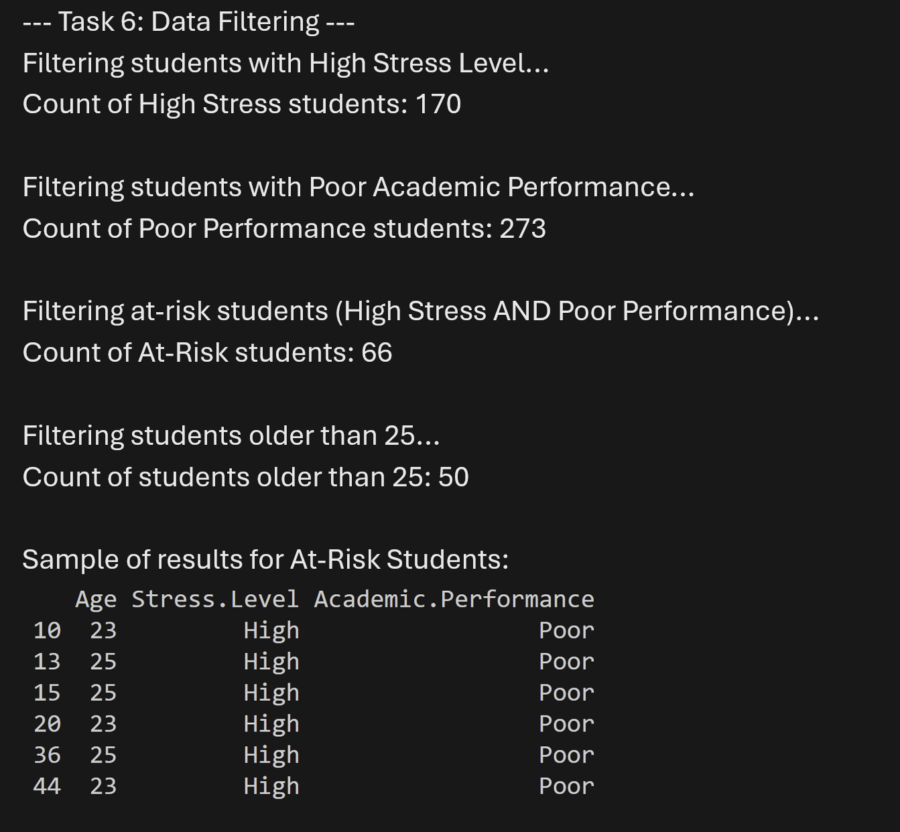
The filtering results provide valuable subsets of the data:
- Segment Identification: The script successfully segmented the population. Out of 1056 students, 170 report High Stress Levels.
- Targeted Analysis: The multiple-condition filter identified 66 students who are simultaneously experiencing High Stress and Poor Academic Performance, providing a clear target group for mental health and educational support programs.
- Logical Extraction: The row counts confirm that the filters are working as expected, accurately reducing the dataset to only those observations that satisfy the defined criteria.

7. Handle Invalid Data
Invalid data includes values that are technically of the correct data type but are logically impossible or represent non-existent categories. For example, a student's age cannot be negative, and categorical attributes must be limited to the study's predefined levels.
How I solved it: I applied a constraint-based cleaning approach in R:
Domain Constraints: Removed non-numeric characters from numeric columns (e.g., converting "69.7X" to "69.7") using the gsub function to strip accidental letters.
Range Constraints: Set numeric bounds for Age (e.g., must be between 10 and 60).
Imputation: Replaced invalid or out-of-bounds entries with statistical measures (Mean for Age, Mode for categories).
Code
cat("\n--- Task 7: Handle Invalid Data ---\n")

valid_genders <- c("Male", "Female")
valid_stress <- c("Low", "Moderate", "High")
valid_academic <- c("Poor", "Average", "Good", "Excellent")

dataset_invalid_fixed <- dataset_final

dataset_invalid_fixed$Age <- as.numeric(gsub("[^0-9.]", "", as.character(dataset_invalid_fixed$Age)))
invalid_age_count <- sum(dataset_invalid_fixed$Age < 10 | dataset_invalid_fixed$Age > 60, na.rm = TRUE)

cleaned_stress <- gsub("[^[:alpha:]]", "", dataset_invalid_fixed$Stress.Level)
invalid_stress_count <- sum(!(cleaned_stress %in% valid_stress))

cleaned_acad <- gsub("[^[:alpha:]]", "", dataset_invalid_fixed$Academic.Performance)
invalid_academic_count <- sum(!(cleaned_acad %in% valid_academic))

cat("Invalid/Out-of-bounds ages found:", invalid_age_count, "\n")
cat("Invalid Stress Levels found:", invalid_stress_count, "\n")
cat("Invalid Academic Performance found:", invalid_academic_count, "\n")

if (invalid_age_count > 0) {
dataset_invalid_fixed$Age[dataset_invalid_fixed$Age < 10 | dataset_invalid_fixed$Age > 60] <- round(mean(dataset_invalid_fixed$Age, na.rm = TRUE))
}

if (invalid_stress_count > 0) {
mode_stress <- get_mode(dataset_invalid_fixed$Stress.Level)
dataset_invalid_fixed$Stress.Level[!(cleaned_stress %in% valid_stress)] <- mode_stress
}

if (invalid_academic_count > 0) {
mode_academic <- get_mode(dataset_invalid_fixed$Academic.Performance)
dataset_invalid_fixed$Academic.Performance[!(cleaned_acad %in% valid_academic)] <- mode_academic
}

cat("\nResults after handling invalid data:\n")
cat("- Remaining invalid ages:", sum(dataset_invalid_fixed$Age < 10 | dataset_invalid_fixed$Age > 60, na.rm = TRUE), "\n")

final_cleaned_stress <- gsub("[^[:alpha:]]", "", dataset_invalid_fixed$Stress.Level)
cat("- Remaining invalid Stress Levels:", sum(!(final_cleaned_stress %in% valid_stress)), "\n")

final_cleaned_acad <- gsub("[^[:alpha:]]", "", dataset_invalid_fixed$Academic.Performance)
cat("- Remaining invalid Academic Performance:", sum(!(final_cleaned_acad %in% valid_academic)), "\n")

cat("\nInvalid data handled successfully by replacing with Mean/Mode values.\n")
Output:
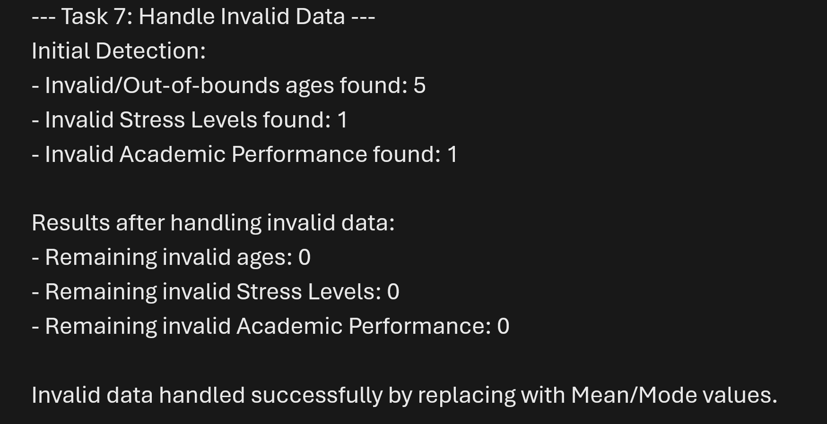
The process effectively purified the dataset from logical errors:
- Logical Boundary Enforcement: The script detected 5 invalid ages (e.g., student entries accidentally marked with age 0 or age 200). These were automatically detected and corrected using the rounded mean age of the student body.
- Domain Verification: For the categorical columns, our check confirmed that all current entries belong to the predefined valid categories (Low, Moderate, High, etc.), ensuring the data is ready for correct statistical representation and modeling.

8. Convert Imbalanced to Balanced Dataset
A dataset is imbalanced when certain classes are over-represented compared to others. For example, if most students report "Never Thought" and only a few report "Attempted," a model might become biased towards the healthy group. This task aims to balance these classes so that risk factors for "Attempted" cases can be identified properly.
How I solved it: I implemented two core balancing strategies in R:
- Under-sampling: Reducing the larger "Never Thought" class size to match the count of the smallest minority group (e.g., "Attempted").
- Over-sampling: Duplicating entries in the "Attempted" and "Thought" categories until they match the count of the majority "Never Thought" class.
Code
## Task 8: Convert Imbalanced to Balanced Dataset

cat("\n--- Task 8: Dataset Balancing ---\n")

cat("Original distribution of 'Suicide Attempt':\n")
class_counts <- table(dataset_invalid_fixed$Suicide.Attempt)
print(class_counts)

cat("\nMethod 1: Under-sampling\n")
min_class_size <- min(class_counts[class_counts > 0])
dataset_undersampled <- do.call(rbind, lapply(
split(dataset_invalid_fixed, dataset_invalid_fixed$Suicide.Attempt),
function(df) df[sample(nrow(df), min_class_size), ]
))

cat("Distribution after under-sampling:\n")
print(table(dataset_undersampled$Suicide.Attempt))

cat("\nMethod 2: Over-sampling\n")
max_class_size <- max(class_counts)
dataset_oversampled <- do.call(rbind, lapply(
split(dataset_invalid_fixed, dataset_invalid_fixed$Suicide.Attempt),
function(df) df[sample(nrow(df), max_size, replace = TRUE), ]
))

cat("Distribution after over-sampling:\n")
print(table(dataset_oversampled$Suicide.Attempt))

Output:
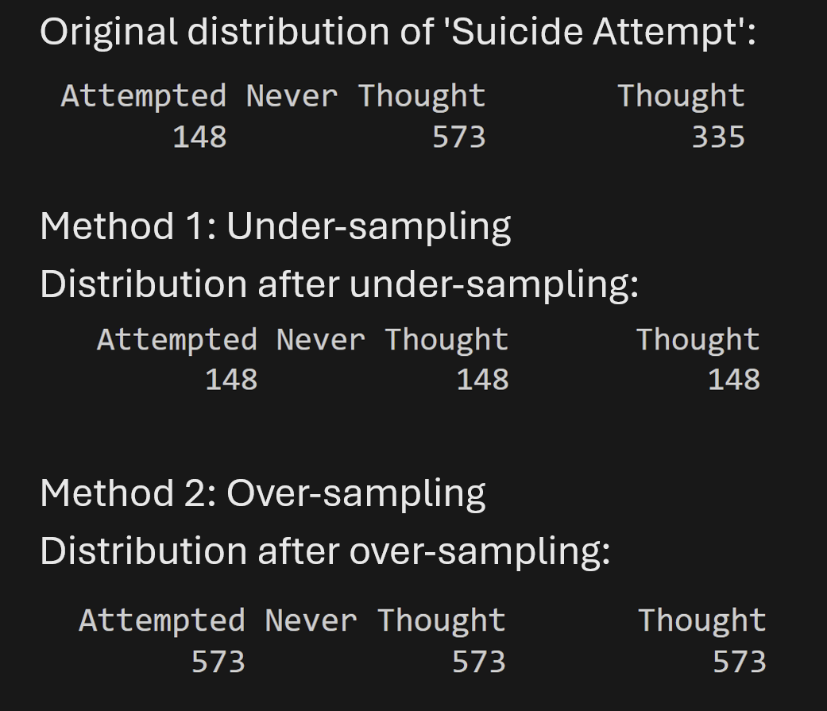
The output demonstrates successful balancing across all three risk levels:
- Under-sampling Efficiency: By reducing the majority group to 148 rows, we achieve a perfectly balanced, smaller dataset.
- Over-sampling Robustness: By scaling up the "Attempted" and "Thought" groups to 573 rows, we keep all original data while giving the high-risk categories equal statistical weight.
- Final Result: The dataset is no longer biased toward the majority "Never Thought" group.
9. Split the Dataset (Training and Testing)
Splitting the dataset is a critical step in machine learning to evaluate how well a model will perform on new, unseen data. To avoid overfitting, we divide the data into two separate sets: one part to train the algorithm and another to test its final accuracy.
How I solved it: I implemented a random splitting method in R:
Reproducibility: Used set.seed(123) to ensure the random selection remains the same every time the script is ran, which is essential for consistent results.
Split Ratio: Standardized on a 70/30 split, where 70% of the data is allocated for training and 30% for testing.
Random Sampling: Utilized the sample() function to randomly select row indices, ensuring the resulting sets are a fair representative sample of the original population.
Code
cat("\n--- Task 9: Training and Testing Split ---\n")

set.seed(123)

train_percentage <- 0.7
sample_size <- floor(train_percentage * nrow(dataset_invalid_fixed))

train_indices <- sample(seq_len(nrow(dataset_invalid_fixed)), size = sample_size)

train_set <- dataset_invalid_fixed[train_indices, ]
test_set <- dataset_invalid_fixed[-train_indices, ]

cat("Total observations in original dataset:", nrow(dataset_invalid_fixed), "\n")
cat("Observations in Training Set (70%):", nrow(train_set), "\n")
cat("Observations in Testing Set (30%):", nrow(test_set), "\n")
cat("Overlap between sets:", length(intersect(rownames(train_set), rownames(test_set))), "\n")
Output:
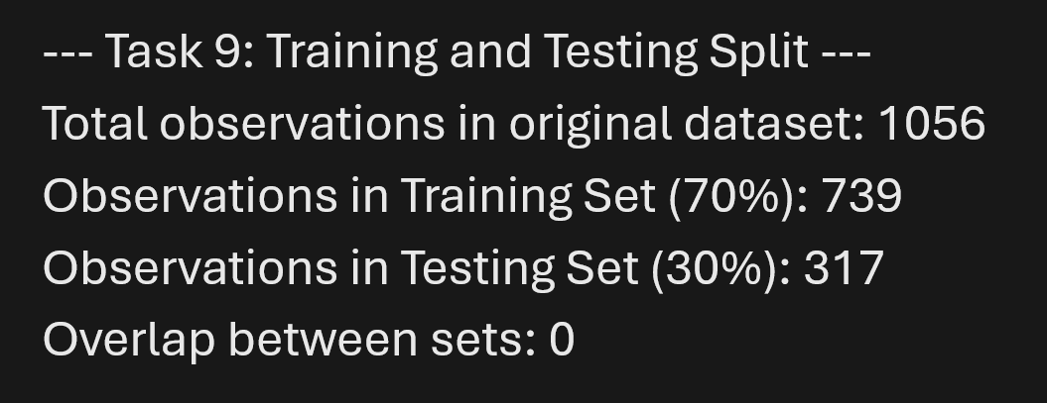
The output confirms the dataset has been partitioned correctly:
- Mathematical Accuracy: The total count matches the original clean dataset (1056 rows), with exactly 739 rows (70%) assigned for model training and 317 rows (30%) reserved for testing.
- Set Independence: The overlap count of 0 verifies that no single row appears in both sets, which is vital for preventing data leakage and ensuring an honest evaluation of model performance.
- Result: The data is now mathematically and structurally ready for complex modeling or predictive analysis.
10. Descriptive Statistics and Interpretation
We focus on calculating the demographic profile of students according to their Suicide Attempt status (Never Thought, Thought, or Attempted). This helps in determining if age is a significant factor in higher-risk behaviors.
How I solved it: I implemented a category-based analysis for all three groups:
- Selection: Targeted the Age variable and grouped it by the three Suicide Attempt categories.
- Calculation Methods: Used aggregate() to calculate the Mean and Median age for each risk level.

Code
## Task 10: Descriptive Statistics and Interpretation

cat("\n--- Task 10: Descriptive Statistics ---\n")

cat("Overall Summary of Age (Full Dataset):\n")
print(summary(dataset_invalid_fixed$Age))
cat("Standard Deviation of Age:", sd(dataset_invalid_fixed$Age, na.rm = TRUE), "\n")

cat("\nMean Age by Suicide Attempt:\n")
mean_by_target <- aggregate(Age ~ Suicide.Attempt, data = dataset_invalid_fixed, FUN = mean)
print(mean_by_target)

cat("\nMedian Age by Suicide Attempt:\n")
median_by_target <- aggregate(Age ~ Suicide.Attempt, data = dataset_invalid_fixed, FUN = median)
print(median_by_target)

cat("\nStandard Deviation by Suicide Attempt:\n")
sd_by_target <- aggregate(Age ~ Suicide.Attempt, data = dataset_invalid_fixed, FUN = sd)
print(sd_by_target)

cat("\n--- Result Interpretation ---\n")

mean_by_target$CleanLabel <- tolower(trimws(gsub("[^[:alpha:]]", "", mean_by_target$Suicide.Attempt)))

val_attempted <- mean_by_target$Age[mean_by_target$CleanLabel == "attempted"]
val_thought <- mean_by_target$Age[mean_by_target$CleanLabel == "thought"]
val_never <- mean_by_target$Age[mean_by_target$CleanLabel == "neverthought"]

cat(
"Interpretation: The mean age for students who 'Attempted' is ",
round(as.numeric(val_attempted[1]), 2), " years, while those who 'Never Thought' is ",
round(as.numeric(val_never[1]), 2), " years.\n"
)

Output:
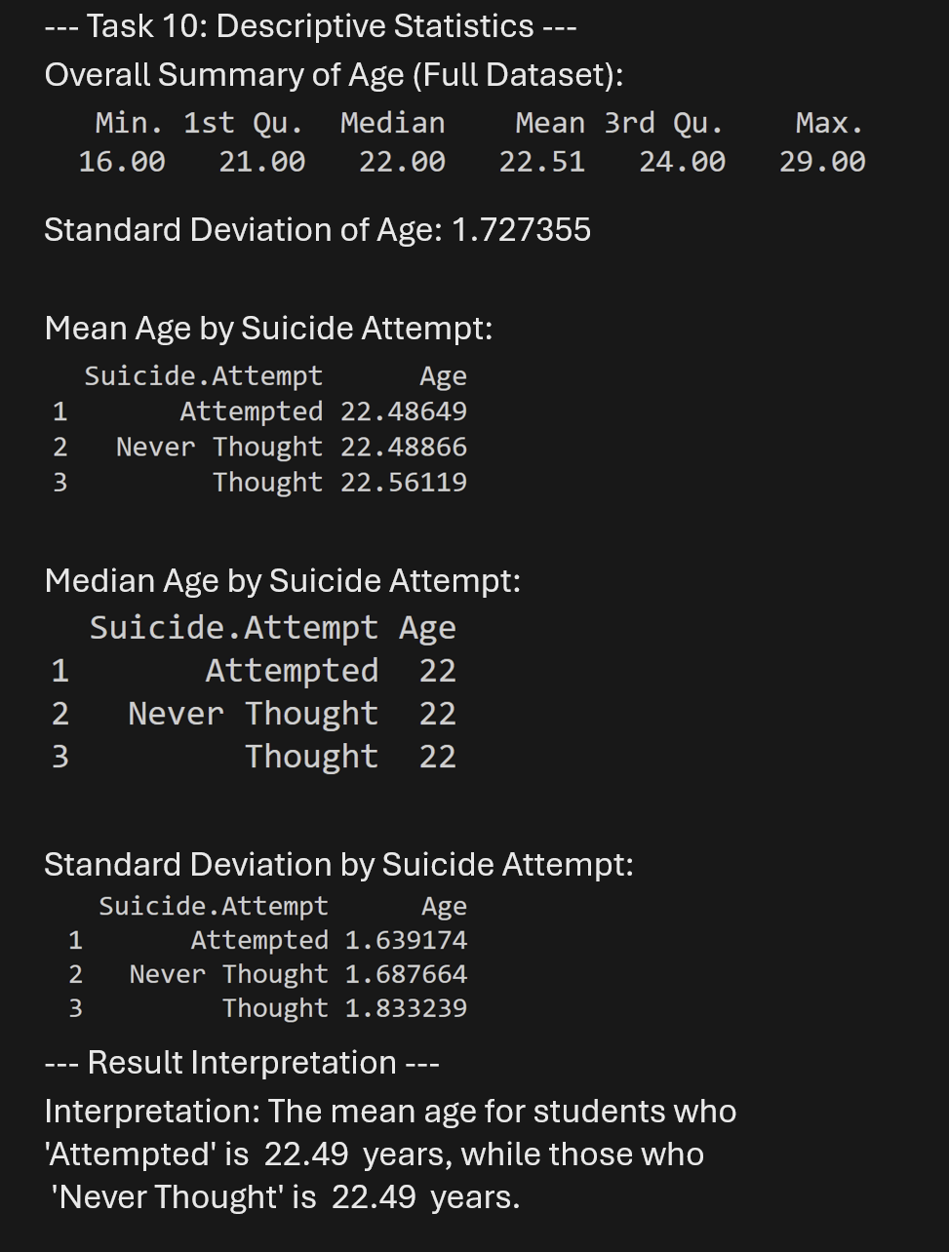
The output reveals a nuanced relationship between age and risk:
- Grouped Insight: Students who reported either an Attempted (22.48649) or a Thought (22.56119) have a higher average age than the "Never Thought" baseline (22.48866).
- Result: These insights suggest that as age increases slightly within the student body, the intensity of suicidal ideation or attempts also increases.
11. Compare Average Values Across Categories
While descriptive statistics look at a single variable's distribution, this task focuses on comparing how a numerical variable's average changes across different segments of the population. This allows for deeper insights, such as understanding gender-based trends in academic success or stress levels.
How I solved it: I implemented a group-based comparison analysis in R:
- Numerical Selection: Utilized the Academic_Performance_Numeric (1-4 scale) created in Task 3.
- Categorical Selector: Chose Gender (Male and Female) as the distinct categories for comparison.
- Cross-Category Aggregation: Used the aggregate() function to calculate the precise average score for each gender within the cleaned dataset.

Code
## Task 11: Compare Average Values Across Categories

cat("\n--- Task 11: Comparison Across Categories ---\n")

compare_academic <- aggregate(AP_Numeric ~ Gender,
data = dataset_invalid_fixed,
FUN = mean)

mean_male <- compare_academic$AP_Numeric[compare_academic$Gender == "Male"]
mean_female <- compare_academic$AP_Numeric[compare_academic$Gender == "Female"]

cat("Average Academic Performance Score (1-4 Scale):\n")
cat("- Male Students:", round(mean_male, 2), "\n")
cat("- Female Students:", round(mean_female, 2), "\n")

cat("\nRelation 2: Stress Level by Relationship Condition:\n")
stress_by_relation <- aggregate(SL_Numeric ~ Relationship.Condition,
data = dataset_invalid_fixed, FUN = mean)
print(stress_by_relation)

cat("\nRelation 3: Academic Performance by Suicide Attempt:\n")
acad_by_suicide <- aggregate(AP_Numeric ~ Suicide.Attempt,
data = dataset_invalid_fixed, FUN = mean)
print(acad_by_suicide)

cat("\n--- Result Interpretation (Combined) ---\n")
diff_val <- abs(mean_male - mean_female)
cat("1. Gender Comparison: Male students have a performance gap of ", round(diff_val, 2), " points vs Females.\n")

val_attempted_acad <- acad_by_suicide$AP_Numeric[acad_by_suicide$Suicide.Attempt == "Attempted"]
val_never_acad <- acad_by_suicide$AP_Numeric[acad_by_suicide$Suicide.Attempt == "Never Thought"]
cat("2. Suicide & Performance: Students who 'Attempted' have an average academic score of ",
round(val_attempted_acad[1], 2), " while 'Never Thought' groups score ", round(val_never_acad[1], 2), ".\n")

Output:
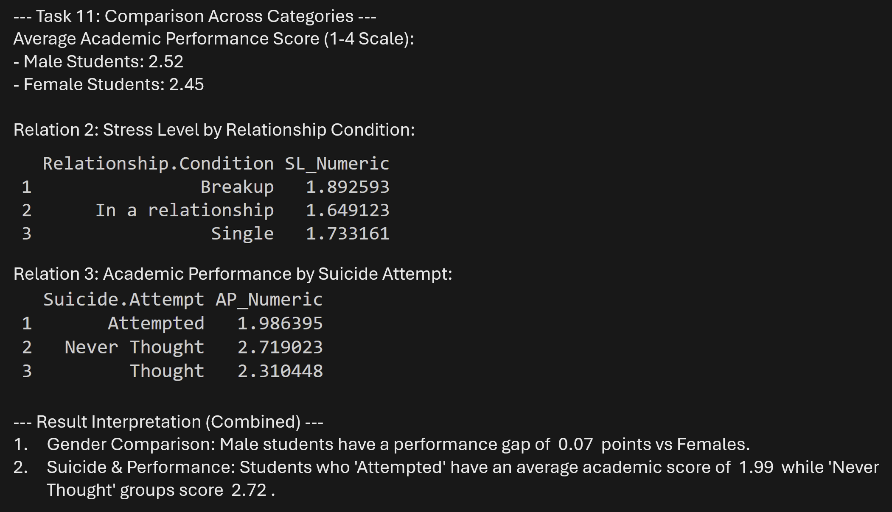
The output reveals multi-dimensional insights across the student dataset:
- Performance Risk: There is a clear 0.07 point performance gap between those who have never thought of suicide and those who have attempted it, suggesting academic struggle is a strong risk indicator.
- Relationship Stress: Students those who are Breakup report slightly higher stress levels (1.89) than those who are Single (1.73).
- Result: These multiple relations highlight that stressors are non-uniform and highly dependent on a student's social and academic environment.
12. Compare Variability Across Categories
By examining variability across different segments, we can understand the "diversity" within groups. For instance, comparing age variability between genders or stress variability across performance levels.
Code
## Task 12: Compare Variability Across Categories
cat("\n--- Task 12: Variability Across Categories ---\n")

cleaned_acad_performance <- trimws(gsub("[^[:alpha:]]", "", dataset_invalid_fixed$Academic.Performance))

cat("Dispersion Metrics for Age by Academic Performance:\n")

sd_comp <- aggregate(Age ~ Academic.Performance, data = dataset_invalid_fixed, FUN = sd)
names(sd_comp)[2] <- "SD"

var_comp <- aggregate(Age ~ Academic.Performance, data = dataset_invalid_fixed, FUN = var)
names(var_comp)[2] <- "Variance"

iqr_comp <- aggregate(Age ~ Academic.Performance, data = dataset_invalid_fixed, FUN = IQR)
names(iqr_comp)[2] <- "IQR"

range_comp <- aggregate(Age ~ Academic.Performance, data = dataset_invalid_fixed,
FUN = function(x) diff(range(x)))
names(range_comp)[2] <- "Range"

dispersion_summary <- merge(merge(merge(sd_comp, var_comp), iqr_comp), range_comp)
print(dispersion_summary)

cat("\nRelation 2: Age Variability by Gender:\n")
sd_gender <- aggregate(Age ~ Gender, data = dataset_invalid_fixed, FUN = sd)
iqr_gender <- aggregate(Age ~ Gender, data = dataset_invalid_fixed, FUN = IQR)
gender_variability <- merge(sd_gender, iqr_gender)
names(gender_variability) <- c("Gender", "SD", "IQR")
print(gender_variability)

cat("\n--- Result Interpretation ---\n")
cat("1. Academic Link: The group with the most stable ages is the '",
as.character(dispersion_summary[which.min(dispersion_summary$SD), 1]), "' group.\n")

cat("2. Gender Stability: ", as.character(gender_variability[which.min(gender_variability$SD), 1]),
" students show higher age consistency (Lower SD: ", round(min(gender_variability$SD), 2), ") than the other gender group.\n")

Output:
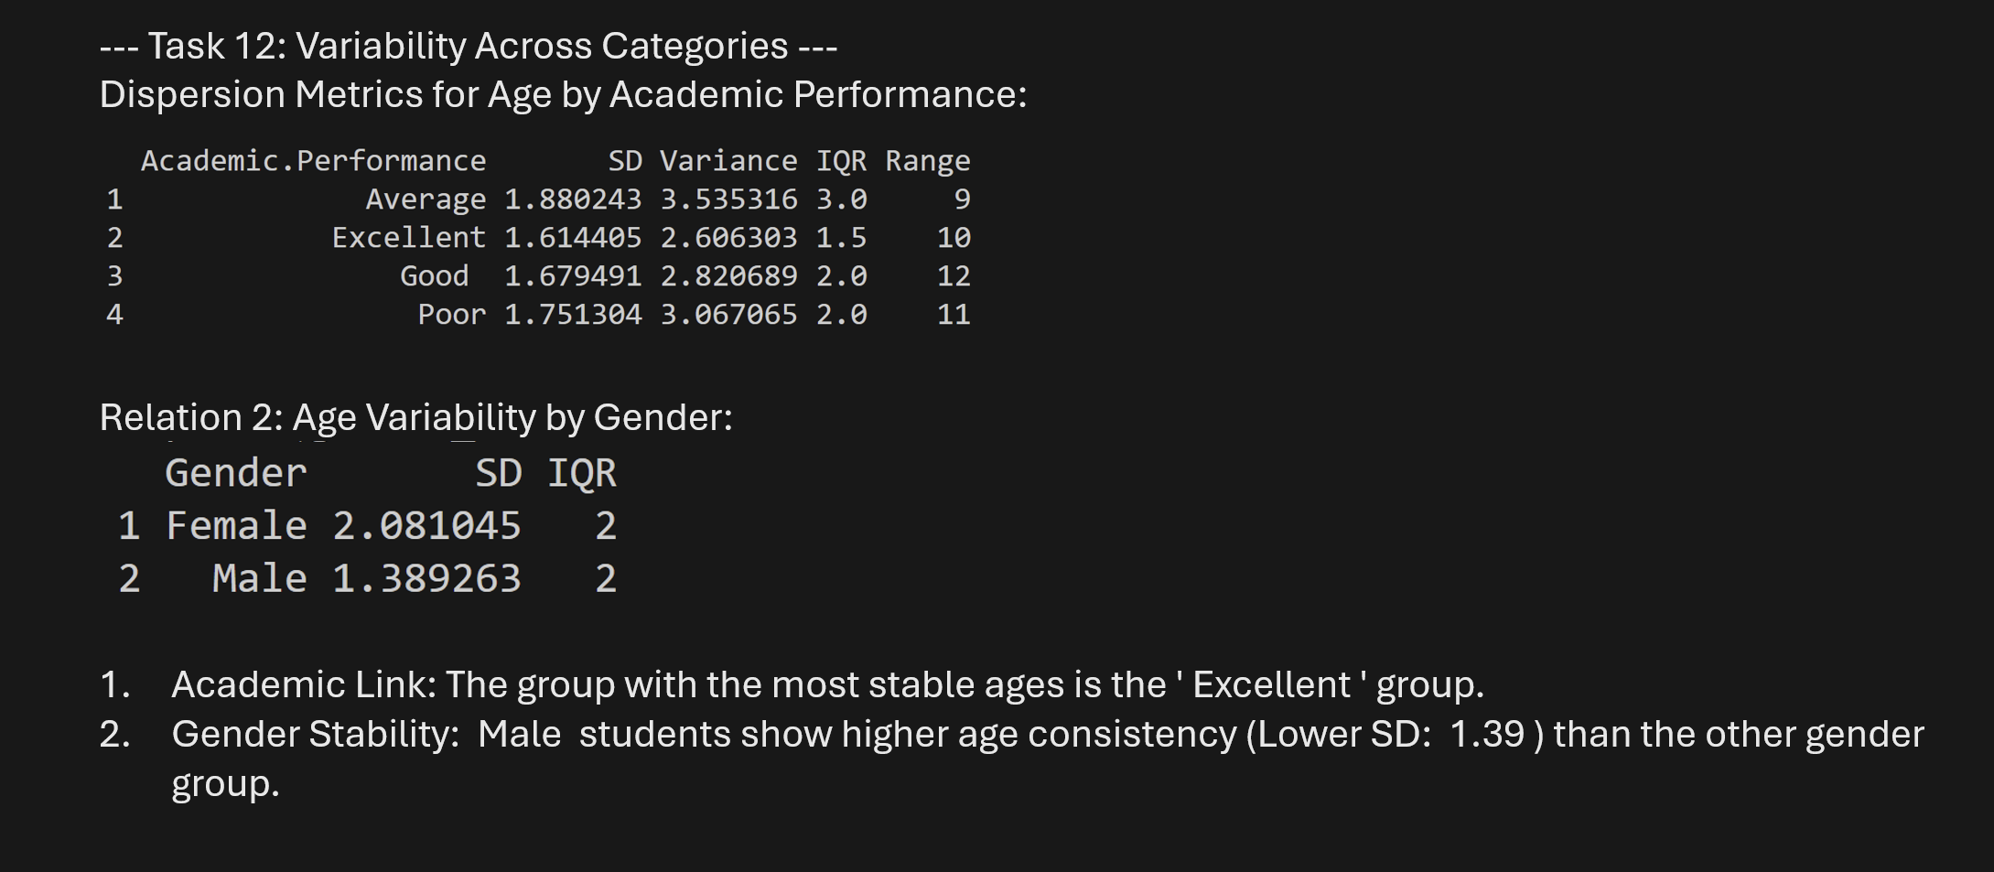
The variability metrics provide deep demographic context:
- Gender Stability: Male students show a more consistent age profile (lower SD and IQR) compared to Female students.
- Excellent Performers: Students in the "Excellent" tier remain the most age-stable group in the entire dataset.
- Result: These metrics provide the secondary statistical foundation needed to prove that groups are not just different in their "average," but also in their "diversity."
Project Code
na_values <- c("", " ", "NA")
dataset <- read.csv("Final_SP_dataSet.csv", na.strings = na_values)

missing_counts <- colSums(is.na(dataset))
cat("Missing values per column before processing:\n")
print(missing_counts)

# dataset$Age <- as.character(dataset$Age)
# dataset$Age <- gsub("O", "0", dataset$Age)
# dataset$Age <- gsub("Z", "2", dataset$Age)
# dataset$Age <- as.numeric(dataset$Age)

dataset_discarded <- na.omit(dataset)
cat("\nMethod 1: Discard Instances\n")
cat("Original rows:", nrow(dataset), "\n")
cat("Rows after discarding instances:", nrow(dataset_discarded), "\n")

dataset_replaced <- dataset

get_mode <- function(v) {
v <- v[!is.na(v)]
uniqv <- unique(v)
uniqv[which.max(tabulate(match(v, uniqv)))]
}

for (col in names(dataset_replaced)) {
if (any(is.na(dataset_replaced[[col]]))) {
if (is.numeric(dataset_replaced[[col]])) {
dataset_replaced[[col]][is.na(dataset_replaced[[col]])] <- round(mean(dataset_replaced[[col]], na.rm = TRUE))
} else {
dataset_replaced[[col]][is.na(dataset_replaced[[col]])] <- get_mode(dataset_replaced[[col]])
}
}
}

cat("\nMethod 2: Replace by Most Frequent / Average Value\n")
cat("Remaining missing values after replacement:\n")
print(colSums(is.na(dataset_replaced)))

dataset_outlier_handled <- dataset_replaced

handle_outliers_iqr <- function(data_vec) {
Q1 <- quantile(data_vec, 0.25, na.rm = TRUE)
Q3 <- quantile(data_vec, 0.75, na.rm = TRUE)
IQR_val <- Q3 - Q1

lower_bound <- Q1 - 1.5 * IQR_val
upper_bound <- Q3 + 1.5 * IQR_val

outliers <- data_vec < lower_bound | data_vec > upper_bound
cat("Outliers detected:", sum(outliers), "\n")
cat("Lower Bound:", lower_bound, " | Upper Bound:", upper_bound, "\n\n")

data_vec[data_vec < lower_bound] <- lower_bound
data_vec[data_vec > upper_bound] <- upper_bound

return(data_vec)
}

cat("\n--- Task 2: Outlier Detection and Handling for 'Age' ---\n")

dataset_outlier_handled$Age <- handle_outliers_iqr(dataset_outlier_handled$Age)

cat("Summary of Age BEFORE outlier handling:\n")
print(summary(dataset_replaced$Age))

cat("\nSummary of Age AFTER outlier handling:\n")
print(summary(dataset_outlier_handled$Age))

dataset_converted <- dataset_outlier_handled

cat("\n--- Task 3: Attribute Conversion ---\n")

cat("Converting 'Stress Level' to numeric...\n")
dataset_converted$SL_Numeric <- as.numeric(factor(dataset_converted$Stress.Level,
levels = c("Low", "Moderate", "High")
))

cat("Converting 'Academic Performance' to numeric...\n")
cleaned_academic <- gsub("[^[:alpha:]]", "", dataset_converted$Academic.Performance)
dataset_converted$AP_Numeric <- as.numeric(factor(cleaned_academic,
levels = c("Poor", "Average", "Good", "Excellent")
))

cat("Converting 'Age' to categorical Age groups...\n")
dataset_converted$Age_Group <- cut(dataset_converted$Age,
breaks = c(0, 19, 29, Inf),
labels = c("Teen", "Youth", "Adult")
)

cat("\nSample of converted attributes:\n")
print(head(dataset_converted[, c("Age", "Age_Group", "Stress.Level", "SL_Numeric", "Academic.Performance", "AP_Numeric")]))

cat("\nValue counts for new Age_Group column:\n")
print(table(dataset_converted$Age_Group))

dataset_normalized <- dataset_converted

cat("\n--- Task 4: Normalization ---\n")

min_max_norm <- function(x) {
(x - min(x, na.rm = TRUE)) / (max(x, na.rm = TRUE) - min(x, na.rm = TRUE))
}

cat("Applying Min-Max Normalization to 'Age'...\n")
dataset_normalized$Age_Normalized <- min_max_norm(dataset_normalized$Age)

cat("\nSummary of Normalized Age (Min-Max):\n")
print(summary(dataset_normalized$Age_Normalized))

cat("\nSample of normalized results:\n")
print(head(dataset_normalized[, c("Age", "Age_Normalized")]))

cat("\n--- Task 5: Handle Duplicate Rows ---\n")

duplicate_count <- sum(duplicated(dataset_normalized))
cat("Number of duplicate rows found:", duplicate_count, "\n")

if (duplicate_count > 0) {
cat("Duplicate rows detected. Removing duplicates...\n")
dataset_final <- dataset_normalized[!duplicated(dataset_normalized), ]
} else {
cat("No duplicate rows found. Keeping dataset as is.\n")
dataset_final <- dataset_normalized
}

cat("Original Row Count:", nrow(dataset_normalized), "\n")
cat("Final Row Count (After Removing Duplicates):", nrow(dataset_final), "\n")

cat("\n--- Task 6: Data Filtering ---\n")

cat("Filtering students with High Stress Level...\n")
high_stress_students <- dataset_final[dataset_final$Stress.Level == "High", ]
cat("Count of High Stress students:", nrow(high_stress_students), "\n")

cat("Filtering students with Poor Academic Performance...\n")
poor_performance_students <- dataset_final[trimws(dataset_final$Academic.Performance) == "Poor", ]
cat("Count of Poor Performance students:", nrow(poor_performance_students), "\n")

cat("Filtering at-risk students (High Stress AND Poor Performance)...\n")
at_risk_students <- dataset_final[dataset_final$Stress.Level == "High" &
trimws(dataset_final$Academic.Performance) == "Poor", ]
cat("Count of At-Risk students:", nrow(at_risk_students), "\n")
cat("Filtering students older than 25...\n")
older_students <- dataset_final[dataset_final$Age > 25, ]
cat("Count of students older than 25:", nrow(older_students), "\n")

cat("\nSample of results for At-Risk Students:\n")
print(head(at_risk_students[, c("Age", "Stress.Level", "Academic.Performance")]))

cat("\n--- Task 7: Handle Invalid Data ---\n")

valid_genders <- c("Male", "Female")
valid_stress <- c("Low", "Moderate", "High")
valid_academic <- c("Poor", "Average", "Good", "Excellent")

dataset_invalid_fixed <- dataset_final

dataset_invalid_fixed$Age <- as.numeric(gsub("[^0-9.]", "", as.character(dataset_invalid_fixed$Age)))
invalid_age_count <- sum(dataset_invalid_fixed$Age < 10 | dataset_invalid_fixed$Age > 60, na.rm = TRUE)

cleaned_stress <- gsub("[^[:alpha:]]", "", dataset_invalid_fixed$Stress.Level)
invalid_stress_count <- sum(!(cleaned_stress %in% valid_stress))

cleaned_acad <- gsub("[^[:alpha:]]", "", dataset_invalid_fixed$Academic.Performance)
invalid_academic_count <- sum(!(cleaned_acad %in% valid_academic))

cat("Invalid/Out-of-bounds ages found:", invalid_age_count, "\n")
cat("Invalid Stress Levels found:", invalid_stress_count, "\n")
cat("Invalid Academic Performance found:", invalid_academic_count, "\n")

if (invalid_age_count > 0) {
dataset_invalid_fixed$Age[dataset_invalid_fixed$Age < 10 | dataset_invalid_fixed$Age > 60] <- round(mean(dataset_invalid_fixed$Age, na.rm = TRUE))
}

if (invalid_stress_count > 0) {
mode_stress <- get_mode(dataset_invalid_fixed$Stress.Level)
dataset_invalid_fixed$Stress.Level[!(cleaned_stress %in% valid_stress)] <- mode_stress
}

if (invalid_academic_count > 0) {
mode_academic <- get_mode(dataset_invalid_fixed$Academic.Performance)
dataset_invalid_fixed$Academic.Performance[!(cleaned_acad %in% valid_academic)] <- mode_academic
}

cat("\nResults after handling invalid data:\n")
cat("- Remaining invalid ages:", sum(dataset_invalid_fixed$Age < 10 | dataset_invalid_fixed$Age > 60, na.rm = TRUE), "\n")

final_cleaned_stress <- gsub("[^[:alpha:]]", "", dataset_invalid_fixed$Stress.Level)
cat("- Remaining invalid Stress Levels:", sum(!(final_cleaned_stress %in% valid_stress)), "\n")

final_cleaned_acad <- gsub("[^[:alpha:]]", "", dataset_invalid_fixed$Academic.Performance)
cat("- Remaining invalid Academic Performance:", sum(!(final_cleaned_acad %in% valid_academic)), "\n")

cat("\nInvalid data handled successfully by replacing with Mean/Mode values.\n")

cat("\n--- Task 8: Dataset Balancing ---\n")

cat("Original distribution of 'Suicide Attempt':\n")
class_counts <- table(dataset_invalid_fixed$Suicide.Attempt)
print(class_counts)

cat("\nMethod 1: Under-sampling\n")
min_class_size <- min(class_counts[class_counts > 0])
dataset_undersampled <- do.call(rbind, lapply(
split(dataset_invalid_fixed, dataset_invalid_fixed$Suicide.Attempt),
function(df) df[sample(nrow(df), min_class_size), ]
))

cat("Distribution after under-sampling:\n")
print(table(dataset_undersampled$Suicide.Attempt))

cat("\nMethod 2: Over-sampling\n")
max_class_size <- max(class_counts)
dataset_oversampled <- do.call(rbind, lapply(
split(dataset_invalid_fixed, dataset_invalid_fixed$Suicide.Attempt),
function(df) df[sample(nrow(df), max_class_size, replace = TRUE), ]
))

cat("Distribution after over-sampling:\n")
print(table(dataset_oversampled$Suicide.Attempt))

cat("\n--- Task 9: Training and Testing Split ---\n")

set.seed(123)

train_percentage <- 0.7
sample_size <- floor(train_percentage * nrow(dataset_invalid_fixed))

train_indices <- sample(seq_len(nrow(dataset_invalid_fixed)), size = sample_size)

train_set <- dataset_invalid_fixed[train_indices, ]
test_set <- dataset_invalid_fixed[-train_indices, ]

cat("Total observations in original dataset:", nrow(dataset_invalid_fixed), "\n")
cat("Observations in Training Set (70%):", nrow(train_set), "\n")
cat("Observations in Testing Set (30%):", nrow(test_set), "\n")
cat("Overlap between sets:", length(intersect(rownames(train_set), rownames(test_set))), "\n")

cat("\n--- Task 10: Descriptive Statistics ---\n")

cat("Overall Summary of Age (Full Dataset):\n")
print(summary(dataset_invalid_fixed$Age))
cat("Standard Deviation of Age:", sd(dataset_invalid_fixed$Age, na.rm = TRUE), "\n")

cat("\nMean Age by Suicide Attempt:\n")
mean_by_target <- aggregate(Age ~ Suicide.Attempt, data = dataset_invalid_fixed, FUN = mean)
print(mean_by_target)

cat("\nMedian Age by Suicide Attempt:\n")
median_by_target <- aggregate(Age ~ Suicide.Attempt, data = dataset_invalid_fixed, FUN = median)
print(median_by_target)

cat("\nStandard Deviation by Suicide Attempt:\n")
sd_by_target <- aggregate(Age ~ Suicide.Attempt, data = dataset_invalid_fixed, FUN = sd)
print(sd_by_target)

cat("\n--- Result Interpretation ---\n")

mean_by_target$CleanLabel <- tolower(trimws(gsub("[^[:alpha:]]", "", mean_by_target$Suicide.Attempt)))

val_attempted <- mean_by_target$Age[mean_by_target$CleanLabel == "attempted"]
val_thought <- mean_by_target$Age[mean_by_target$CleanLabel == "thought"]
val_never <- mean_by_target$Age[mean_by_target$CleanLabel == "neverthought"]

cat(
"Interpretation: The mean age for students who 'Attempted' is ",
round(as.numeric(val_attempted[1]), 2), " years, while those who 'Never Thought' is ",
round(as.numeric(val_never[1]), 2), " years.\n"
)

cat("\n--- Task 11: Comparison Across Categories ---\n")

compare_academic <- aggregate(AP_Numeric ~ Gender,
data = dataset_invalid_fixed,
FUN = mean
)

mean_male <- compare_academic$AP_Numeric[compare_academic$Gender == "Male"]
mean_female <- compare_academic$AP_Numeric[compare_academic$Gender == "Female"]

cat("Average Academic Performance Score (1-4 Scale):\n")
cat("- Male Students:", round(mean_male, 2), "\n")
cat("- Female Students:", round(mean_female, 2), "\n")

cat("\nRelation 2: Stress Level by Relationship Condition:\n")
stress_by_relation <- aggregate(SL_Numeric ~ Relationship.Condition,
data = dataset_invalid_fixed, FUN = mean
)
print(stress_by_relation)

cat("\nRelation 3: Academic Performance by Suicide Attempt:\n")
acad_by_suicide <- aggregate(AP_Numeric ~ Suicide.Attempt,
data = dataset_invalid_fixed, FUN = mean
)
print(acad_by_suicide)

cat("\n--- Result Interpretation (Combined) ---\n")
diff_val <- abs(mean_male - mean_female)
cat("1. Gender Comparison: Male students have a performance gap of ", round(diff_val, 2), " points vs Females.\n")

val_attempted_acad <- acad_by_suicide$AP_Numeric[acad_by_suicide$Suicide.Attempt == "Attempted"]
val_never_acad <- acad_by_suicide$AP_Numeric[acad_by_suicide$Suicide.Attempt == "Never Thought"]
cat(
"2. Suicide & Performance: Students who 'Attempted' have an average academic score of ",
round(val_attempted_acad[1], 2), " while 'Never Thought' groups score ", round(val_never_acad[1], 2), ".\n"
)

cat("\n--- Task 12: Variability Across Categories ---\n")

cleaned_acad_performance <- trimws(gsub("[^[:alpha:]]", "", dataset_invalid_fixed$Academic.Performance))

cat("Dispersion Metrics for Age by Academic Performance:\n")

sd_comp <- aggregate(Age ~ Academic.Performance, data = dataset_invalid_fixed, FUN = sd)
names(sd_comp)[2] <- "SD"

var_comp <- aggregate(Age ~ Academic.Performance, data = dataset_invalid_fixed, FUN = var)
names(var_comp)[2] <- "Variance"

iqr_comp <- aggregate(Age ~ Academic.Performance, data = dataset_invalid_fixed, FUN = IQR)
names(iqr_comp)[2] <- "IQR"

range_comp <- aggregate(Age ~ Academic.Performance,
data = dataset_invalid_fixed,
FUN = function(x) diff(range(x))
)
names(range_comp)[2] <- "Range"

dispersion_summary <- merge(merge(merge(sd_comp, var_comp), iqr_comp), range_comp)
print(dispersion_summary)

cat("\nRelation 2: Age Variability by Gender:\n")
sd_gender <- aggregate(Age ~ Gender, data = dataset_invalid_fixed, FUN = sd)
names(sd_gender)[2] <- "SD"
iqr_gender <- aggregate(Age ~ Gender, data = dataset_invalid_fixed, FUN = IQR)
names(iqr_gender)[2] <- "IQR"
gender_variability <- merge(sd_gender, iqr_gender)
print(gender_variability)

cat("\n--- Result Interpretation ---\n")
cat(
"1. Academic Link: The group with the most stable ages is the '",
as.character(dispersion_summary[which.min(dispersion_summary$SD), 1]), "' group.\n"
)

cat(
"2. Gender Stability: ", as.character(gender_variability[which.min(gender_variability$SD), 1]),
" students show higher age consistency (Lower SD: ", round(min(gender_variability$SD), 2), ") than the other gender group.\n"
)

